Sprint 2

|  |  |
| --- | --- |
| **Team ID** | PNT2022TMID51856 |
| **Project Name** | Industry-specific Intelligent Fire Management System |

# Configuring IBM IoT Platform and sending data to IBM cloud

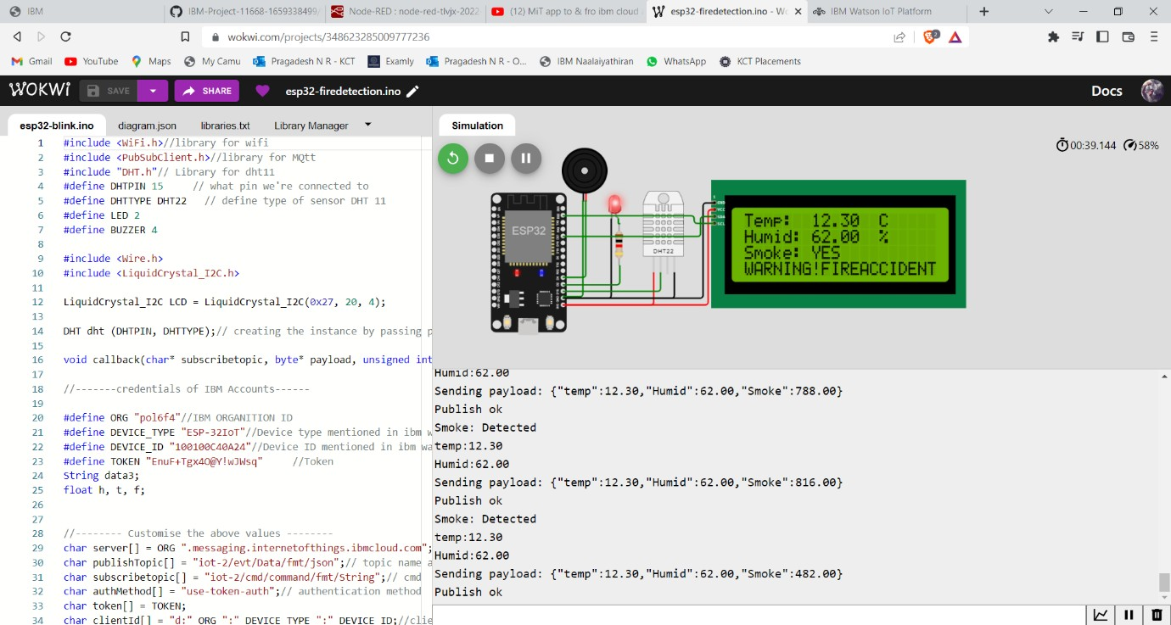

**Fire Detection & Indication in LCD Screen**

**The IBM cloud details included in code**

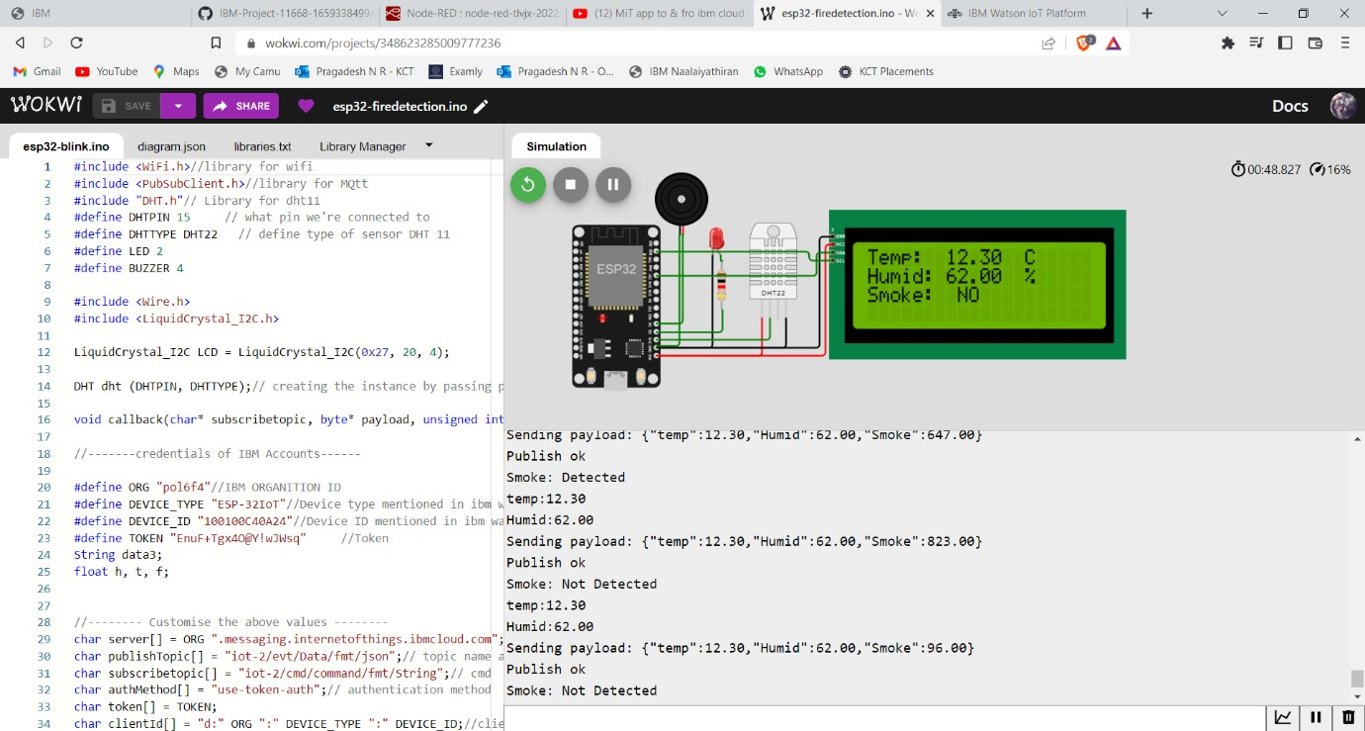

**Fire Detection & Indication in LCD Screen**

**Sending Sensor Data to IBM Cloud**

**Publishing Sensor Data & Receiving in IBM Cloud**

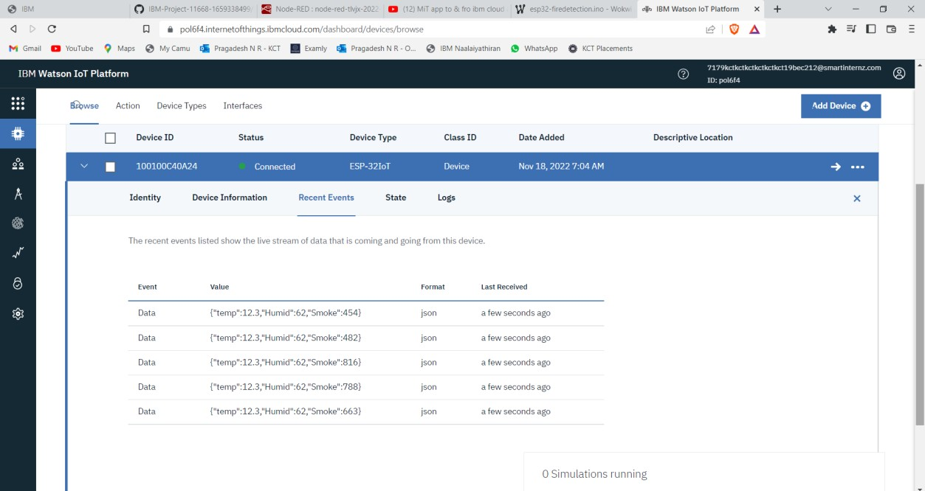

**Sensor Data Received in IBM Cloud**

# Sprint 2 - Coding:

#include <WiFi.h> #include <PubSubClient.h> #include "DHT.h"

#define DHTPIN 15 #define DHTTYPE DHT22 #define LED 2

#define BUZZER 4

#include <Wire.h>

#include <LiquidCrystal_I2C.h>

LiquidCrystal_I2C LCD = LiquidCrystal_I2C(0x27, 20, 4); DHT dht (DHTPIN, DHTTYPE);

void callback(char* subscribetopic, byte* payload, unsigned int payloadLength);

#define ORG "pol6f4"

#define DEVICE_TYPE "ESP-32IoT" #define DEVICE_ID "100100C40A24"

#define TOKEN "EnuF+Tgx4O@Y!wJWsq" String data3;

float h, t, f;

char server[] = ORG ".messaging.internetofthings.ibmcloud.com"; char publishTopic[] = "iot-2/evt/Data/fmt/json";

char subscribetopic[] = "iot-2/cmd/command/fmt/String"; char authMethod[] = "use-token-auth";

char token[] = TOKEN;

char clientId[] = "d:" ORG ":" DEVICE_TYPE ":" DEVICE_ID;

WiFiClient wifiClient;

PubSubClient client(server, 1883, callback ,wifiClient);

void setup()

{

**Serial**.begin(115200); dht.begin(); pinMode(LED,OUTPUT); pinMode(BUZZER,OUTPUT);

digitalWrite(LED,LOW); digitalWrite(BUZZER,LOW); delay(10); **Serial**.println(); wificonnect(); mqttconnect(); LCD.init(); LCD.backlight(); LCD.setCursor(0, 0);

LCD.print("Connecting to "); LCD.setCursor(0, 1); LCD.print("WiFi "); delay(1000);

LCD.clear();

}

void loop()

{

LCD.setCursor(0,2); LCD.print("Smoke: "); LCD.setCursor(0, 0); LCD.print("Temp: "); LCD.setCursor(14, 0); LCD.print("C"); LCD.setCursor(0, 1); LCD.print("Humid: "); LCD.setCursor(14, 1); LCD.print("%");

h = dht.readHumidity();

t = dht.readTemperature();

f = random(0,900); if (f>300)

{

**Serial**.print("Smoke: "); **Serial**.println("Detected"); digitalWrite(LED,HIGH); digitalWrite(BUZZER,HIGH); LCD.setCursor(7, 2); LCD.print("YES");

LCD.setCursor(0, 3); LCD.print("WARNING!FIREACCIDENT");

}

else{

**Serial**.print("Smoke: "); **Serial**.println("Not Detected"); digitalWrite(LED,LOW); digitalWrite(BUZZER,LOW); LCD.setCursor(7, 2); LCD.print(" NO"); LCD.setCursor(0, 3);

LCD.print(" ");

}

**Serial**.print("temp:"); **Serial**.println(t); LCD.setCursor(7, 0); LCD.print(t); **Serial**.print("Humid:"); **Serial**.println(h); LCD.setCursor(7, 1); LCD.print(h);

PublishData(t, h, f); delay(1000);

if (!client.loop()) { mqttconnect();

}

}

void PublishData(float temp, float humid, float smoke) {

mqttconnect();

String payload = "{\"temp\":"; payload += temp;

payload += "," "\"Humid\":"; payload += humid;

payload += "," "\"Smoke\":"; payload += smoke;

payload += "}";

**Serial**.print("Sending payload: ");

**Serial**.println(payload);

if (client.publish(publishTopic, (char*) payload.c_str())) {

**Serial**.println("Publish ok");

} else {

**Serial**.println("Publish failed");

}

}

void mqttconnect() {

if (!client.connected()) { **Serial**.print("Reconnecting client to "); **Serial**.println(server);

while (!!!client.connect(clientId, authMethod, token)) {

**Serial**.print("."); delay(500);

}

initManagedDevice();

**Serial**.println();

}

}

void wificonnect()

{

**Serial**.println(); **Serial**.print("Connecting to ");

WiFi.begin("Wokwi-GUEST", "", 6); while (WiFi.status() != WL_CONNECTED) {

delay(500);

**Serial**.print(".");

}

**Serial**.println(""); **Serial**.println("WiFi connected"); LCD.setCursor(0, 0); LCD.print("Connected"); **Serial**.println("IP address: "); **Serial**.println(WiFi.localIP());

}

void initManagedDevice() {

if (client.subscribe(subscribetopic)) { **Serial**.println((subscribetopic)); **Serial**.println("subscribe to cmd OK");

} else {

**Serial**.println("subscribe to cmd FAILED");

}

}

void callback(char* subscribetopic, byte* payload, unsigned int payloadLength)

{

**Serial**.print("callback invoked for topic: ");

**Serial**.println(subscribetopic);

for (int i = 0; i < payloadLength; i++) { data3 += (char)payload[i];

}

**Serial**.println("data: "+ data3); if(data3=="lighton")

{

**Serial**.println(data3); digitalWrite(LED,HIGH);

}

else

{

**Serial**.println(data3); digitalWrite(LED,LOW);

}

data3="";

}